Click or tap to enter a date
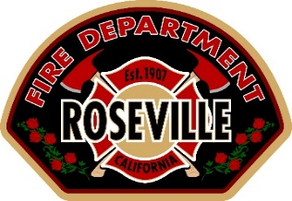
City of Roseville
Fire Department - Plan Review & Inspection Services
316 Vernon Street, Suite 480
Roseville, CA 95678

Attn: Jason Rizzi, jrizzi@roseville.ca.us

Permit Application Number: Insert Here
Project Address: Insert Here

Dear Sir:

This letter is to certify that I have reviewed the proposed rack plans, and based on my knowledge of the NFPA 13 provisions for rack storage configuration, determine that the existing installation of the automatic fire sprinkler system meets the required fire protection per NFPA 13 and the Roseville Fire Code.

The existing automatic fire protection system located at the above address has been reviewed by Insert Name, with Insert Company for code compliance with the adopted edition of NFPA 13 and the Roseville Fire Code. I assure that the storage height, flue spaces, shelving types, commodity classifications, and aisle width dimensions meet the requirements of the Fire Department.

(In this section provide storage height, reference code page numbers, code edition, code sections, figures, area reduction tables required for the proposed storage, etc.)

(In this section provide existing density and area of application provided)

My analysis shows that the existing automatic fire sprinkler system is adequate for the proposed rack storage installation and that the existing system will not have to be upgraded.

Sincerely,

Insert Name
Insert Title
Insert Phone Number
Engineering Seal & Expiration Date

